**Topic 6: Hedge Funds**

Convertible Arbitrage

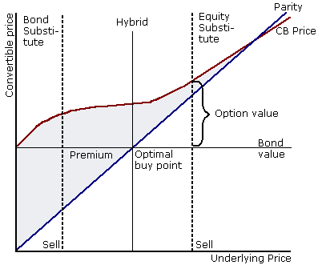

* Asset swap
* At-the-money convertibles
* Busted convertible bond
* Call protection
* Conversion premium
* Conversion price
* Conversion ratio
* Convertible price
* Delta hedging
* Equity proxy convertible bond
* Hybrid convertible bond
* In-the-money convertibles
* Junk (distressed) convertible bond
* Net delta
* Out-of-the-money convertibles
* Parity
* Risk-neutral probability
* Vega hedging

**1. Explain the economic basis for the source of return for the convertible arbitrage strategy.**

* + Convertible bonds give the owner the right to exchange them for shares.
  + In its simplest form, the convertible arbitrage strategy involves purchasing convertible bonds and hedging away various risk associated with the instrument, including the equity risk, credit risk and interest rate risk.
  + The goal is to isolate, underpriced options embedded in convertible bonds.
  + Corporations can issue new equity without the administrative costs of a straight equity issue.
  + From the issuer's perspective, the key benefit of raising money by selling convertible bonds is a reduced cash interest payment. However, in exchange for the benefit of reduced interest payments, the value of shareholder's equity is reduced due to the stock dilution expected when bondholders convert their bonds into new shares.
  + In-the-money: Conversion Price is < Equity Price.
  + At-the-money: Conversion Price is = Equity Price.
  + Out-the-money: Conversion Price is > Equity Price

**2. Understand the terminology of convertible bonds.**

* Conversion ratio: Number of shares obtained if one converts 1000 face of the bond. Can be as low as eight.
* Conversion price: Price at which shares are directly purchased. 900/8 = 112.50
* Conversion premium is the difference between the convertible bond price and parity, expresses as a percentage of parity

**3. Calculate the value of convertible securities using the component approach: Valuation of a straight bond and valuation of a call option on the underlying stock. Pg. 312**

* Component Approach:

Convertible bond = straight bond + call option on the underlying stock

**4. Explain the behavior of a typical convertible bond price in response to changes in interest rates, changes in the equity price of the underlying stock, changes in market volatility, and changes in the credit risk of the underlying firm.**

* Convertibles always dampen the downside of the stock market.
* Interest rates:

Rho becomes more important as the convert acts more like a bond. So, to the left of the graph.

* Equity price of underlying stock:

When the stock price is so low, the call option is worth zero

* Volatility:

Greater volatility heightens the value of the call.

So, you can convert the bonds into equity. Probably most important at ATM.

* Credit risk of the firm:

Convert is said to be deep out of the money.

**5. Calculate the value of convertible securities using the binomial model. Calculate the binomial trees for:**

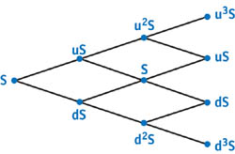

U = probability. D = 1/u

a. stock price

Tree – with u x Stock price and d x Stock price. Two branch trees u x u x Stock price

b. parity

c. conversion probability

* Prob Conv x (1+R) + (1-Prob Conv) x (1+R+Cs)

d. credit-adjusted discount rate

Prob Conv x (1+R) + (1-Prob Conv) x (1+R+Cs) -

e. convertible bond value

* p x conv value + (1-p) x conv value) / 1 + discount rate + Coupon

**6. Understand the following concepts regarding THE GREEKS of convertible bonds:**

a. calculate and explain delta and modified delta, and calculate the binomial tree for the delta of the convertible bond



* (124.11 – 91.38) / (107.99 – 59.27) = .672
* Modified delta: some arbiters use a modified delta - it implicitly incorporates the impact of other Greeks in the calculation, in particular the gamma. ‘
* This was used with your ORC application. Remember: Mod Delta.

b. calculate and explain gamma



* Gamma = Change in the Delta / Change in the Stock price
* = (.793-.406) / (107.99 – 59.27)
* Gamma is greatest for ATMs

c. explain vega

* Volatility component

d. explain rho

* Interest rate component

e. discuss other Greeks: Chi, Omicron, Upsilon and Phi.

* Chi: is an estimate of the rate of change of a convertible’s value to change in the spot exchange rate
* Omicron: is an estimate of the rate of change of a convertible value to change in the credit spread
* Upsilon: is an estimate of the rate of change of a convertible’s value to change in the credit recovery rate
* Phi: is an estimate of the rate of change of a convertible value to change in the underlying stock’s dividend rate.

**7. Explain and illustrate an arbitrage situation involving convertible bonds.**

**Understand and explain delta hedging and gamma hedging. Explain and illustrate how a convertible arbitrageur uses an asset swap to manage credit risk.**

* The asset swap is a key development that has boosted the demand for convertible bonds in recent years. This new instrument offers the ability the ability to split a convertible bond into its two components: the fixed income part and the equity call options.
* Asset swaps may take several alternative forms, but their basic function remains the same, i.e. to split the convertible bond into its two core components.

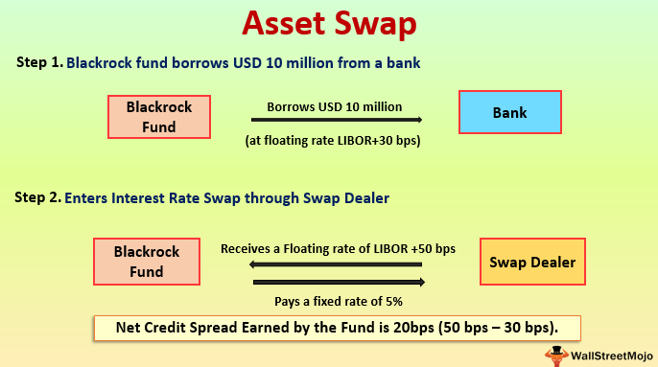

**8. Describe the salient features of the historical performance of the convertible arbitrage** strategy.

* From 1990 to 2008, the CISDM Convertible Arbitrage Index exhibited an annualized return of 8.35%.
* The convertible arbitrage strategy exhibited moderate correlation to equity markets.

Global Macro



* Carry trade
* Covered Interest Rate Parity
* Exchange rate risk
* Forward (currency) premium
* Purchasing Power Parity (PPP)
* Uncovered Interest Rate Parity (UIP)
* Yield curve relative value trade
* Learning Objectives

**1. Compare and contrast the investment process of discretionary versus systematic global macro managers. Pg 331**

* Discretionary global macro managers usually perform intensive fundamental research.

* Systematic global macro managers apply a highly structured, disciplined, and repeatable investment process.

**2. Understand and apply the Purchasing Power Parity.**

* PPP: In its "absolute" version, the purchasing power of different currencies is equalized for a given basket of goods.
* In the "relative" version, the difference in the rate of change in prices at home and abroad—the difference in the inflation rates—is equal to the percentage depreciation or appreciation of the exchange rate.
* PPP implies the ratio between domestic and foreign price levels should be equal to the equilibrium exchange rate between domestic and foreign currencies. Mangers use these models when looking at relative values between currencies.

**3. Compare and contrast the three schools of thought on the sources of returns that Global Macro funds endeavor to tap:**

* Feedback based

Markets are rational most of the time, but there are periods of severe irrationality

* Information based

Global macro managers rely primarily on collecting micro information to better understand the global macro picture.

* Model based

Global macro managers rely primarily on collecting micro level information to better understand the global macro picture.

**4. Discuss the main elements of a directional currency bet as illustrated by the**

**Exchange Rate Mechanism (ERM) crisis in 1992-1993.**



* ERM agreement allowed several European currencies to float within pre-specified bands.
* Britain’s economy began to weaken while others, such as Germany’s remained strong.
* Soros SHORTS the POUND
* Black Wednesday occurred on 16 September 1992 when the [British government](https://en.wikipedia.org/wiki/Government_of_the_United_Kingdom) was forced to withdraw the [pound sterling](https://en.wikipedia.org/wiki/Pound_sterling) from the [European Exchange Rate Mechanism](https://en.wikipedia.org/wiki/European_Exchange_Rate_Mechanism) (ERM), after a failed attempt to keep the pound above the lower [currency exchange](https://en.wikipedia.org/wiki/Bureau_de_change) limit mandated by the ERM. At that time, the United Kingdom held the [Presidency of the European Communities](https://en.wikipedia.org/wiki/Presidency_of_the_Council_of_the_European_Union).
* In the months leading up to Black Wednesday, among many other currency traders, [George Soros](https://en.wikipedia.org/wiki/George_Soros) had been building a huge [short position](https://en.wikipedia.org/wiki/Short_(finance)) in pounds sterling that would become immensely profitable if the pound fel/l below the lower band of the ERM. Soros believed the rate at which the United Kingdom was brought into the Exchange Rate Mechanism was too high, inflation was too high (triple the German rate), and British interest rates were hurting their asset prices

**5. Discuss the main elements of spread plays as exemplified by carry trades.**

1. Carry trades
2. Curve Steepening

**6. Explain and apply the Covered Interest Rate Parity.**

* Covered IRP: the forward premium of one currency relative to another is equal to the interest rate differential between them.

**7. Discuss contingent yield curve steepening.**

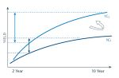

* In February 2000, following the 1998 Russian default and the collapse of LTCM.
* What occurred was a zero-cost bet on the yield curve steepening between 2 and 10 years.
* American FED changed rates, but Europe did not.
* Overall result was therefore essentially a free contingent claim on the yield curve steepening.
* Global macro fund managers love these positions because they have very little downside and very large potential upside.

**8. Describe the role of global macro hedge funds during the Asian currency crisis in 1997.**

* Global macro managers were accused of accumulating large, concentrated short position that destabilized Asian foreign exchange markets and compromised market integrity.
* The IMF conducted an investigation and found NO EVIDENCE of hedge funds causing the Asian currency problems.

**9. Discuss the basics of risk management and portfolio construction in the context of global macro strategies.**

* In their youth, global macro funds were primarily one-man shops placing directional bets with a lot of leverage and very few risk controls. Their volatility was extremely high and large losses were frequent.

**10. Describe the main elements of the historical performance of the global macro strategy.**

* Best years were in the 1990s. Particularly during periods of currency or liquidity crises.
* From 1990 to 2008, global macro funds delivered average returns of 11.18% per year with volatility of 6.66%.

Equity Long/Short

 Note: “Long/Short”

* 130/30 funds
* Anomalies
* Blend approach
* Bottom-up
* Corporate governance (Activists)
* approach
* Equity long/short
* Factor-mimicking portfolios
* Fama-French four factor model
* Growth approach
* Margin cost of longs
* Margin cost of shorts
* Momentum
* Quantitative approach
* Sector investment approach
* Short rebate
* Top-down
* Valuation based approach
* Value approach
* Winsorized -- gets rid of outliers.
* Z-scoring – distance from the mean

**1. Describe the basics of the equity long/short strategy.**

* Is an investment strategy associated with hedge funds whose managers buy equities that are expected to rise in value and sell equities that are expected to fall in value.

**2. Discuss the evolution of value-investing.**

* Alford Winslow Jones is the grandfather of the hedge fund industry, and then Tiger Fund’s Julian Robertson should be the father of the long/short strategy.

**3. Describe the mechanics of the equity long/short strategy, as depicted by the following steps:**

a. idea generation

The most critical, is to generate good ideas.

b. optimal idea expression

How best to express the idea

c. sizing the position

Has does the new position fit within the context of her current portfolio.

d. executing the trade

Need to consider whether to buy or sell aggressively.

e. managing the risk

Portfolio positions are monitored closely to see if the investment idea is working

**4. Discuss the sources of return to the equity long/short strategy.**

Sources of return – otherwise known as Alpha.

**5. Explain various investment approaches employed by equity long/short managers.**

* Value approach
* Growth approach
* Blend approach
* Quantitative approach
* Valuation base approach

**6. Discuss the sources of return to the equity long/short strategy by reviewing investment opportunity sets.**

1) What is the market capitalization?

2) Where is the company located, and are regional investments a focus?

**7. Illustrate and calculate the returns attributed to four components from the long positions and five components from the short positions.**

Long positions

1. Price increase/decrease
2. Dividends received
3. Margin cost of longs
4. Interest earned on cash position

Short positions

1. Price increase/decrease
2. Short rebate
3. Borrowing (of shares) costs
4. Dividend payments to purchasers of borrowed shares
5. Margin costs of shorts

**8. Compare the equity long/short strategy to the following other strategies:**

1. Equity market neutral strategy

Compared to equity market neutral managers, equity long/short managers have a greater correlation to market returns.

1. Long-only and 130/30 mutual funds

Compared to long only managers, equity long/short managers have returns that are less correlated with market returns.

130/30 funds have the ability to short securities.

**9. Compare and contrast the advantages and disadvantages of the following four investment strategies:**

1. equity long/short
2. equity market neutral
3. 130/30
4. long only equity mutual funds

Note: 130/30 and long only funds are required to publish the NAV on a daily basis

**10. Describe the Fama-French four factor model and explain how factor mimicking portfolios are typically created.**

4 Factors for Fama-French.

1. Excess return to Market
2. High book value minus low book value (HML)
3. Small minus big (SMB)
4. Up minus down (UMD)

HSU

* NOTE: Factor replication follows a stepwise linear regression to derive replicating portfolio with the goals of matching the return of the target hedge fund.
* Pay off replication uses an option payoff Model

**11. Describe the salient features of the historical performance of the equity long/short strategy.**

Performance of long/short equities is better because short selling can be important for achieving higher returns with lower volatility.

Fund-of-Hedge-Funds and Investible Indices



pg 365 in big book

* Access bias
* Balanced funds of hedge funds
* Concentrated fund of hedge funds
* Double layer of fees
* Instant history bias
* Multi-strategy fund of hedge funds
* Negotiated fees
* Selection bias
* Single-strategy fund of hedge funds
* Survivorship bias

**1. Discuss the basics of the following three approaches for accessing hedge funds:**

1. Self-Managed
2. Delegated Fund of Hedge Funds
3. Indexed

**2. Explain the main characteristics of funds of hedge funds (FoHFs) and their approach to diversification.**

* Single
* Multiple
* Balanced
* Concentrated

**3. Explain why certain biases found in hedge fund databases may not impact FoHFs.**

* Reduced survivorship bias
* No selection bias
* No instant history bias
* Reduced database bias

**4. Explain the benefits and the potential disadvantages offered by funds of hedge funds.**

Advantages:

* diversification
* Accessibility and economies of scale,
* information advantage
* Liquidity
* access to certain managers
* regulation
* currency hedging

Disadvantages:

* double layer of fees
* lack of transparency
* Taxes

**5. Compare and contrast funds of hedge funds vs. individual hedge funds.**

* A fund of funds is a pooled investment vehicle that simply invests in other funds. This differs from, say, a hedge fund (which selects securities and actually runs the investment when it comes to stock selection / futures trading / commodities / options / vol trading, etc) or a private equity or venture capital fund who invest and manage the portfolio of investments directly in private companies.
* Fund of funds typically consider themselves more of “asset allocators” and “manager selectors,” in that they interview and seek to identify the best investment managers out there and hope to invest with them.
* Fund of funds are more diversified (generally speaking) than hedge funds, as they often invest across the spectrum: they may be invested in a few hedge fund event-driven global macro managers, some long/short US equity managers, some international managers, some private equity, some real estate investment managers, etc.

**6. Explain the three means through which a fund of hedge funds (FOHF) manager can add value**.

1. Strategically allocate to various hedge fund styles. More long term.
2. Tactically allocate across hedge funds. Tactical is based on changing market conditions which will improve performance. Hint: changing winds – sailing tact.
3. Select individual Managers

**7. Explain how FoHFs may help reduce the number of poorly managed hedge funds. How does this claim measure up in the context of hedge fund due diligence and the fraud case associated with Madoff Investment Securities, LLC?**

Fund of Funds would have discovered his game with Due Diligence.

* Madoff delivered an impressive total return of 11.2% per month/year with a volatility of 2.5%, no down year, and almost no negative months. Fraud lasted 17 years

**8. Explain the desirable properties of investment indices.**

* Unambiguous
* Verifiable
* Accountable
* Investible
* Reasonable

**9. Compare and contrast non-investible hedge fund indices versus investible hedge fund indices.**

Non-investible

* No transparency
* Hard to rebalance
* Reporting time lag

Investible

* Have the problem of Access Bias (which hedge funds to include)

**10. Discuss and apply the main Due Diligence issues arising in the context of funds of hedge funds.**

* Background
* Product information
* Performance
* Asset allocation / style
* Due diligence / manager selection
* Portfolio construction
* Risk management
* Administration/operations
* Client information/reporting
* Compliance/legal

Strategic Specific Due Diligence



* Capital structure arbitrage
* Contagion risk
* Covered short selling
* Frontier markets
* Gross exposure
* Manager alpha
* Market-linked returns
* Mortgage arbitrage
* Naked short selling
* Net exposure
* Reverse merger
* Static returns
* Stop-loss
* Swap spread arbitrage
* Volatility arbitrage
* Yield curve arbitrage

**1. Assess, explain and apply the main strategy specific issues arising in a**

**Due Diligence process in the cases of the following hedge fund strategies:**

1. long/short equity

b. convertible arbitrage

c. merger arbitrage

Managers invest in the spread created between the share prices of two merging companies.

d. fixed income arbitrage

Managers invest in swap spread arbitrage or yield curve arbitrage.

e. emerging markets

Managers invest in equity and/or debt of less developed countries.

f. distressed securities

Managers generally take long positions in the debt of rims that are reorganizing, in bankruptcy, or are experience some type of financial distress.

* Seniority
* Active or passive leverage
* Liquidity
* Side pockets

Operational Risk

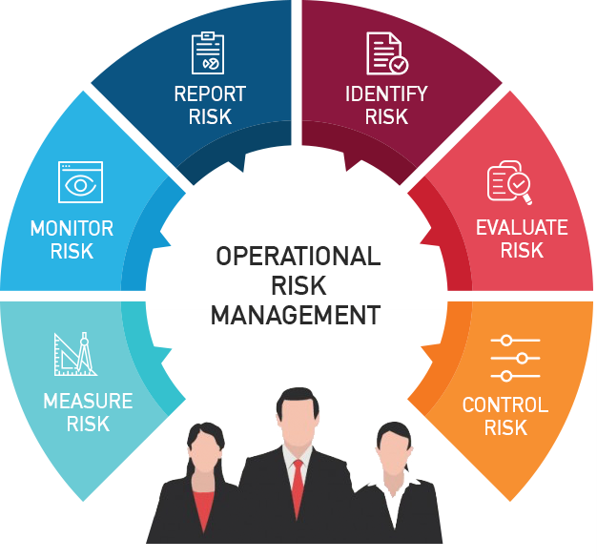

* Agency risk
* Assessment phase
* Background checks
* Credit risk
* Economic capital (EC)
* Expected loss (EL)
* Focus phase
* Form ADV
* Forward curve
* Market risk
* Private placement memorandum
* Validation phase
* Learning Objectives

**1. Explain the basics of the measures of market risk and credit risk.**

Market risk:

* Value at Risk (VaR): worst loss that is expected under normal markets conditions given a certain time horizon and a certain confidence internal.
* Conditional Value at Risk (CVaR): measures the average expected loss under abnormal market conditions and is an extension of VaR.

Credit risk:

* Expected Loss: measures the expected credit loss over a specified time horizon.
* Economic Capital: amount of capital a hedge fund must maintain to cover a worst case scenario in terms of credit losses.

**2. Discuss the due diligence issues, the early warning signs and the main lessons of the following well publicized hedge fund “blow-ups”:**

a. The Bayou funds



* Pure fraud. Created a fictitious auditing firm to fulfill the independent oversight function. They hid losses by fabricating financial records and drastically misrepresenting the firm’s financial performance.
* Had their own broker-dealer firm.
* No independent auditor
* His vehicle was found abandoned on the Bear Mountain Bridge over the Hudson River in New York with the words "Suicide is Painless" written in the dust on his hood

1. Amaranth



* Risk Management was the issue
* In 2005, Brian Hunter had positioned his trading book in anticipation of soaring natural gas prices. It was successful when Hurricane Katrina struck.

c. Madoff

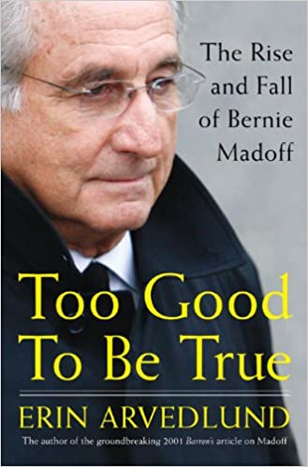

Promised 8%- 12% a year with low volatility.

Average 11.2% a year with a volatility of 2.5%.

**3. Assess the operational risk of a hedge fund, including the following elements:**

a. a typical operational and due diligence process FAV

1. Focus Phase
2. Assessment Phase
3. Validation Phase

b. key focus areas

* Valuation
* Auditors
* Prime Brokers
* Compliance
* Human Resources
* Conflicts of Interest
* Past Behavior
* Investor Base
* Administration

c. liquidity risk

* Redemption gates
* Suspend redemptions
* Liquidation trusts
* Payment in specie
* Side pockets

d. the case of MANAGED ACCOUNTS

1. Standard custodial arrangements
2. Prime brokerage custody
3. Basic managed accounts
4. Manager account platforms

Account is managed by someone else.

Advantages:

* Misappropriation of assets is less likely
* Independent valuation
* Transparency
* Liquidity

Disadvantages:

* Monitoring costs
* Relevance of transparency
* Division of profits
* Smaller universe of fund managers
* Audit costs
* Counterparty risk

e. operational ratings

In 2006, Moody’s started issuing operational ratings for hedge funds.

|  |
| --- |
| oq1: excellent |
| oq2: very good |
| oq3: good |
| oq4: fair |
| oq5: poor |

**4. Assess the operational risk of a fund of hedge funds multi-strategy fund, discussing the advantages, weaknesses and historical performance of multi-strategy hedge funds.**

Advantages:

* flexibility,
* single layer of fees

Disadvantages:

* agency risk,
* excessive span of control,
* potential for subpar managers,
* talent retention,
* operational risk

Historical performance of multi strategy hedge funds: Has been relatively good. Delivered an average return of 11.05% per years with a standard deviation of returns of 6.6%. The return distribution is negatively skewed. The maximum drawdown is about 50% of the S&P 500 Index.

11.05%

6.6%

Passive Hedge Fund Replication: A Critical Assessment of Existing Techniques

* Conditional factor models
* Payoff distribution approach
* Factor –replication approach
* Time varying factor exposure

**1. Compare the factor replication approach to hedge fund replication with the payoff distribution approach to hedge fund replication, in terms of their goals, methodology, and ability to replicate hedge fund returns. :**

Factor-based hedge fund replication

* Goal: almost equal and attempts to mirror the return.
* Methodology:
* Returns:
* Benefits: Intuitive, constant parameters
* Drawbacks: Model specification risk

Payoff distribution replication

* Goal: equal in distribution
* Methodology:
* Returns:
* Benefits: VaR, 2nd,3rd,4th movements are similar to clones
* Drawbacks: Parameter estimations

Hedge Fund Investing in Distressed Securities

 Note: “Distressed”

* Busted convertibles
* Debtor-in-possession loans
* Distressed debt instruments
* PIPEs
* Seller paper
* Stubs

**1. Characterize the US markets that the majority of distressed managers focus on.**

1. High Yield Bonds
2. Leveraged Loans (bank debt of non-investment grade companies)

**2. Describe four phases of the credit cycle and determine the best phases of the credit cycle to invest in distressed securities.**

#1 and #4 – Early Recovery and Recession End

1. Recession ends/recovery begins. Credit Spreads Tighten. Hint: Recovery-right and tight
2. Recovery/bull market. Credit spreads continue to tighten while equity markets are rising
3. Late recovery/recession begins. Credit spreads are rising
4. Recession/bear market. Both equity and credit are in a bear market

**3. Explain why the drop in leveraged loan prices was particularly severe during the most recent market correction.**

2008 Correction – Severe decline in leveraged loans prices in early 2008.

1. Overhang in new issuances -- too much supply
2. Disappearance of CLOs
3. Declining LIBOR

**4. Define distressed debt instruments and describe types of distressed securities. Pg 190**

1. High yield bonds
2. Below par bank loans
3. Debtor in possession loans
4. Second lien notes
5. Seller paper
6. Trade claims/receivable
7. Busted convertibles CDS
8. Credit default indices
9. Preferred stock
10. PIPES
11. Collateralized debt
12. Bond and loan obligations
13. Futures
14. Options
15. Swaps

* A debtor in possession (DIP) is a person or corporation that has filed for Chapter 11 bankruptcy protection but still holds property to which creditors have a legal claim under a lien or other security interest.
* Debtor in possession (DIP) is typically a transitional stage in which the debtor attempts to salvage value from assets after bankruptcy.
* Although DIPs often exercise substantial influence over assets in their possession, creditors can ultimately use courts to force the sale of DIP assets.
* The key advantage to DIP status is to be able to continue running a business, albeit with the power and obligation to do so in the best interest of any creditors.

**5. Explain how hedge fund managers trade distressed securities across the lifecycle of a troubled company.**

* Schweser says not to worry about matching a strategy with each stage.
* Mid Bankruptcy Stage is best for investments - when turn around starts.

1. Pre default
2. Early bankruptcy
3. Mid bankruptcy
4. Late bankruptcy
5. Emergence

**6. Describe the size and growth of the distressed hedge fund universe.**

* 9.4% of the entire hedge fund universe was managed by distressed hedge funds as at December 2007

**7. Characterize the investment strategy of distressed hedge funds including the use and aspects of top-down and bottom-up approaches, the use of leverage, and aspects of the risk management process.**

* Top Down is Macro – more strategy. Macro.
* Bottom up is micro - individual company level
* Unlike other hedge fund strategies, distressed hedge funds NO LEVERAGE

**8. Compare and contrast distressed investing for private equity and hedge funds, and active and passive approaches to distressed investing.**

* Passive managers are more trading oriented, benefit from cyclical opportunities and tend to focus on large caps.
* Active managers can further split into control and non-control. Active control managers get more involved in the daily business of their target company
* Active no control managers on the other hand do not lead restructurings, even though they own a large enough chunk of the company’s shares.

**9. Describe the following distressed investing sub-strategies:**

a. Outright short

Bearish views on the credit fundamentals of a company

b. Long/short

go long undervalued companies

c. Capital structure arbitrage

Analyze mispricing between securities of the same issuer and generate profits by taking a long position in the security that is higher in the capital structure and a short position in the security that is lower in the capital structure or vice versa

d. Value/deep value

Mangers focus on finding securities they believe are undervalued

e. Rescue financing

Lending to a company that is experiencing cash flow problems

**10. Explain why performance of distressed hedge funds may not be highly correlated with returns in the high yield bond market and discuss the determinants of distressed hedge fund performance over the period from 1994 to the beginning of 2008, and the rationale for opportunities existing in the credit markets in early 2008. (Candidates do not need to memorize exact performance statistics.)**

* Distressed funds are less correlated with the whole market. It is really specific to event risk.

Are Funds of Funds Simply Multi-Strategy Managers with Extra Fees???



Integrated Topics and Applications

* Fee netting
* Headline risk
* Manager selection
* Strategy allocation

**1. Describe the goal of the study by Reddy, Brady, and Patel, their rationale for using historical data of underlying managers from the TASS database and the criteria they used to choose the data.**

* Goal: The authors note that there is little examination between Fund of Hedge Funds and Multi Strategy Funds.
* Rational for using historical data: The authors contend that the time period is more indicative of the current hedge fund environment. In addition, data availability falls off sharply when including data more than five years prior to 2007.
* They examined performance reported in the Lipper TASS database for the period 1994-2004, and found that multi-strategy hedge funds significantly outperformed hedge fund of funds on both an absolute and risk adjusted basis.

**2. Explain the potential impact of strategy selection and manager selection on the performance of a hedge fund portfolio and compare the results to those related to traditional asset classes.**

* Strategy selection is more important than Manager selection.

**3. Describe the potential performance differences between multi-strategy managers and funds of hedge funds in terms of strategy allocation and manager selection and describe the assumptions underlying this conclusion.**

* While multi-strategy managers have an advantage with respect to strategy allocation, manager selection is an area of potential advantage for funds of funds.
* A fund of funds can select managers from a large, global universe of hedge fund, whereas a multi-strategy manager is limited by its ability to hire outstanding teams within each strategy in which it participates.
* Two Key Assumptions:

1. Capital was allocated across strategies in the same proportions as the CSFB Hedge Fund Index
2. Managers had the benefit of perfect foresight

**4. Discuss the relative benefits of diversification in FoHFs and multimanager funds.**

* Funds of funds typically offer greater strategy diversification, as well as manager diversification.
* FoHFs offer additional diversification benefits based both on the Sharpe and Sortino ratios (risk-adjusted performance).

**5. Discuss the relative impacts of the operational risk and fraud and headline risk of funds of funds and multi-manager funds.**

* Operational Risk (Fund of funds):

The additional diversification provided by funds of dunds can potentially reduce the market risk associated with hege fund investing.

* Fraud and Headline Risk (Fund of funds):

Because hedge funds represent a relatively new style of invesing for many institutions, there is often heightened concernt about the potential for adverse publicity. Fund of funds provides an additional level of due diligence and monitoring the can be beneficial.

* Operational Risk (Multi-manager):

Investing in multi strategy is like investing in a conglomerate, whereas investing in a fund of funds is like investing in a mutual fun. One of the risk of investing in a conglomerate is that if one business unit has problems, it can impact the entire business.

**6. Compare the business models of funds of funds and multi-strategy funds from the investor’s perspective, particularly with respect to fee structures and manager talent.**

* Fund of funds business model:

A fund of funds (FOF) is a pooled fund that invests in other funds. FOFs usually invests in other hedge funds or mutual funds. The fund of funds (FOF) strategy aims to achieve broad diversification and minimal risk. Funds of funds tend to have higher expense ratios than regular mutual funds.

* Multi-strategy business model:

The most obvious advantage of multi strategy hedge funds over funds of funds is the potential for lower fees.

A less obvious fee advantage of multi strategy managers is the fact that unprofitable strategies are automatically “netted” against profitable ones before any incentive fees are paid.

Another business issue that investors should consider when analyzing a successful multi-strategy hedge funds is the ability of the fund to retain talent.